GEMINI HISTORICAL ARTIFACT DESCRIPTION APP
SmartBridge Virtual Internship Project

Team Details
Team ID: LTVIP2026TMIDS61478
Team Size: 4
Team Leader:
Dabbakuti Veera Venkata ManiKanta Raju
Team Members:
Vaddi Sasi Kumar
Muzavarapu Mabhu Subhani
Shaik Sahil

1. INTRODUCTION
1.1 Project Overview
This project, titled “Gemini Historical Artifact Description App,” is developed as part of the SmartBridge Virtual Internship Program. The objective of this project is to generate detailed descriptions of historical artifacts using Artificial Intelligence and Generative AI technology.
In today’s digital era, students, historians, and researchers often require quick and structured information about historical artifacts. Manual research can be time-consuming and information may be scattered across multiple sources. This project provides an intelligent solution that enables users to generate artifact descriptions automatically.
The system accepts artifact names and optional images from users. The input is processed using Google’s Gemini Generative AI model, which generates informative and structured descriptions. The application demonstrates the real-world use of Artificial Intelligence in education and research.

1.2 Purpose
The main purpose of this project is to apply theoretical knowledge of Artificial Intelligence and Python programming to build a practical real-world application.
This project helps in understanding:
- API integration
- Web application development
- Prompt engineering
- AI model interaction
It also improves technical and problem-solving skills.

2. IDEATION PHASE
2.1 Problem Statement
Many students and researchers need structured descriptions of historical artifacts for academic and educational purposes. Searching and compiling information manually requires significant time and effort.
There is a need for a system that:
- Generates descriptions automatically
- Provides structured content
- Is easy to use
This project solves the problem using Generative AI.

2.2 Empathy Map Canvas
What the User Thinks
- Wants quick information about artifacts
- Needs accurate and clear descriptions
What the User Feels
- Frustrated searching multiple sources
- Satisfied when results are generated quickly
What the User Says
- “I need a description of this artifact.”
- “I want reliable historical information.”
What the User Does
- Searches online
- Reads articles
User Pain Points
- Time-consuming research
- Information scattered
User Needs
- Quick generation
- Easy interface

2.3 Brainstorming
Different approaches were considered:
- Manual research systems
- Database-based artifact information
- AI-based description generation
AI-based generation was selected because it provides better scalability and faster results.

3. REQUIREMENT ANALYSIS
3.1 Customer Journey Map
User workflow:
- User opens the application
- User enters artifact name
- User uploads image (optional)
- System processes input
- AI generates description
- Output displayed

3.2 Solution Requirements
Functional Requirements
- Accept artifact name
- Accept image upload
- Generate descriptions
- Display output
Non-Functional Requirements
- Easy to use
- Fast response
- Reliable
- Secure API handling

3.3 Data Flow Diagram
User → Streamlit UI → Gemini API → Generated Description → Output

3.4 Technology Stack
Programming Language:
- Python
Framework:
- Streamlit
Libraries:
- Google GenAI
- Python-dotenv
- Pillow
Tools:
- VS Code
- GitHub
Platform:
- Windows OS
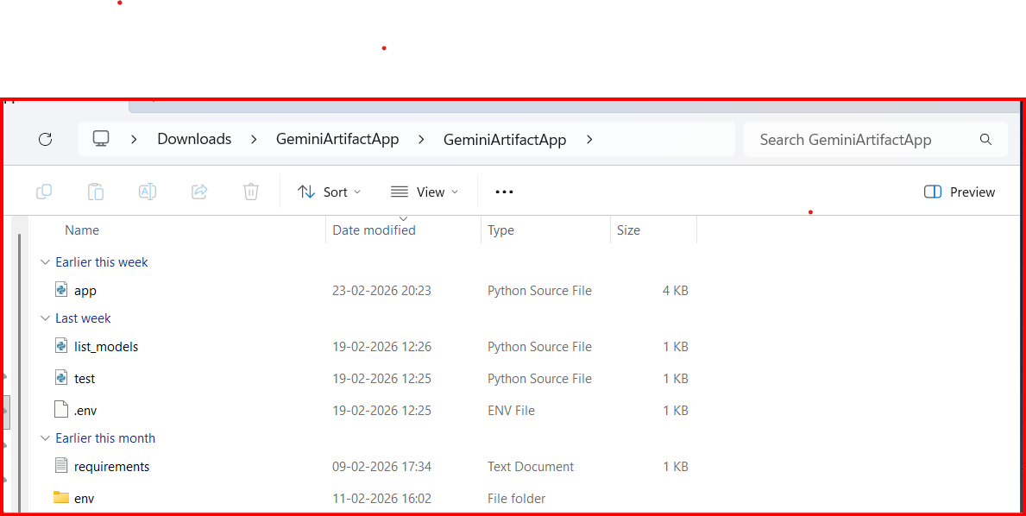

4. PROJECT DESIGN
4.1 Problem–Solution Fit
The problem identified is the difficulty of obtaining structured artifact descriptions quickly.
The proposed AI-based solution automates the process and generates meaningful content efficiently.

4.2 Proposed Solution
The system works as follows:
- User enters artifact name
- User uploads image (optional)
- Prompt sent to Gemini
- Description generated
- Output displayed

4.3 Solution Architecture
Components:
- User Interface (Streamlit)
- API Integration Layer
- Gemini AI Model
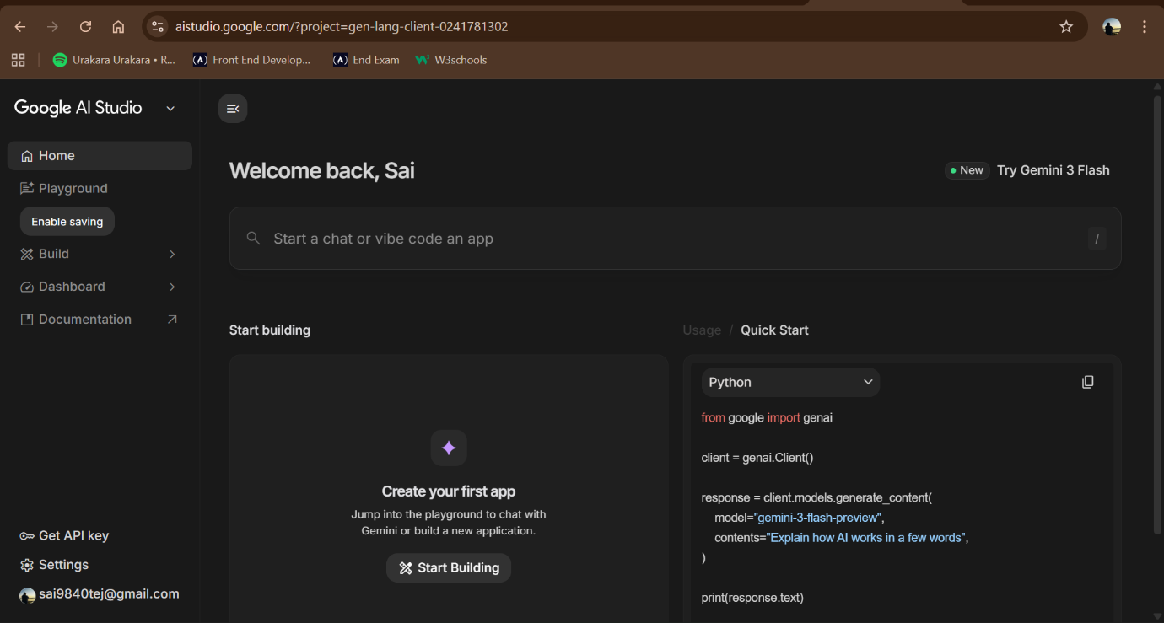
- Output Display Module

5. PROJECT PLANNING AND SCHEDULING
Project Phases
- Requirement Analysis
- System Design
- Development
- Testing
- Documentation
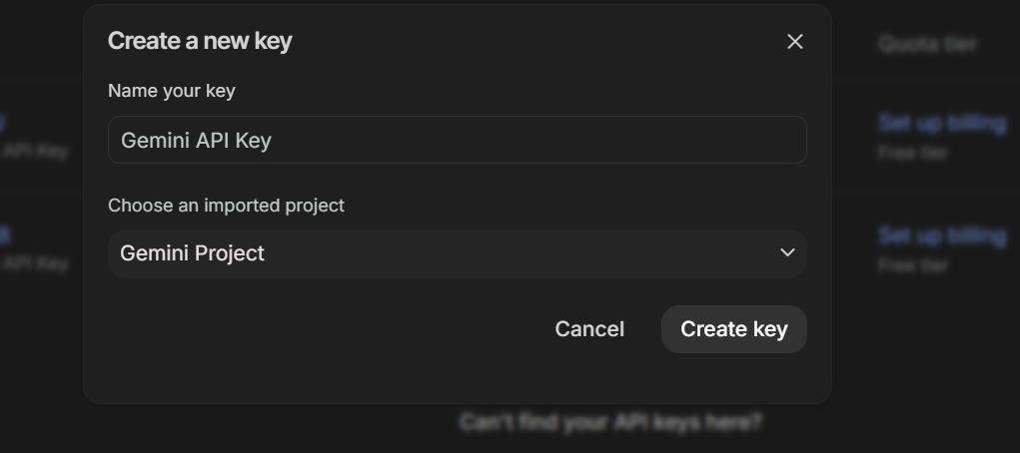
Schedule
Phase | Activity | Duration
Phase 1 | Requirement Analysis | 3 Days
Phase 2 | Design | 3 Days
Phase 3 | Development | 7 Days
Phase 4 | Testing | 4 Days
Phase 5 | Documentation | 3 Days

6. FUNCTIONAL AND PERFORMANCE TESTING
6.1 Functional Testing
- Verified text input
- Verified image upload
- Verified AI integration
- Verified output display
6.2 Performance Testing
- Checked response time
- Tested UI interaction
- Verified stability

7. RESULTS
The application successfully:
- Accepts user input
- Generates descriptions
- Displays output correctly

7.2 Output Screenshots
Insert screenshots here:
Figure 1: Main Interface of the Application
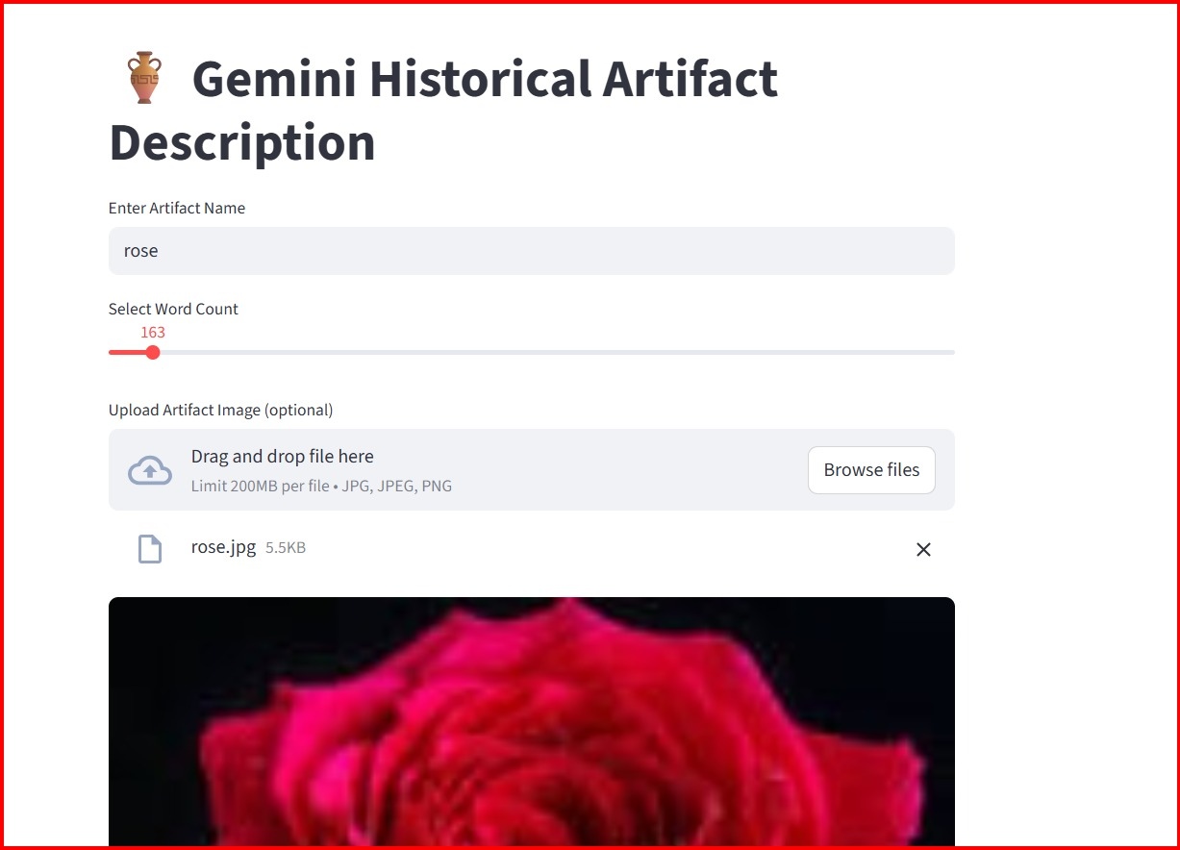

Figure 2: Sample Artifact Image Used


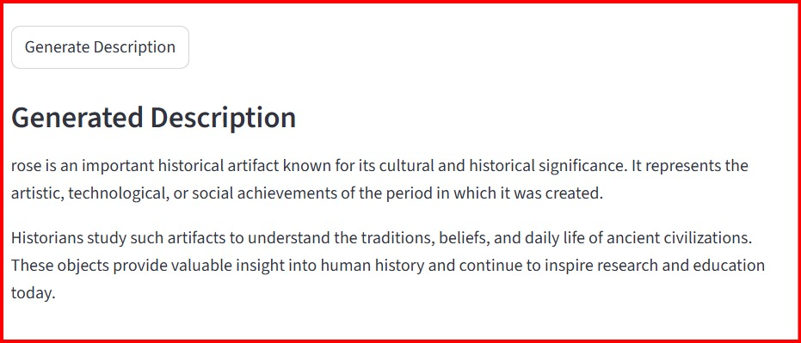

8. ADVANTAGES AND DISADVANTAGES
Advantages
- Easy to use
- Fast generation
- AI integration
- Lightweight
Disadvantages
- Requires internet
- API quota limitations

9. CONCLUSION
This project demonstrates the integration of Generative AI with a web application. The system successfully generates historical artifact descriptions and provides a simple and effective interface.

10. FUTURE SCOPE
- Download option
- Cloud deployment
- Multi-language support
- Mobile version

11. APPENDIX
11.1 Security Implementation
- API key stored in .env
- Not hardcoded
- .env ignored in Git

11.2 Project Demo
🔗 Demo Video:
C:\Users\rajud\Desktop\genai4.2\demo.mp4
The demo shows:
- Artifact input
- Image upload
- AI-generated output

11.3 References
- Google Gemini API
- Streamlit Documentation
- Python Documentation

